MCj03843580000[1]MCj03843580000[1] 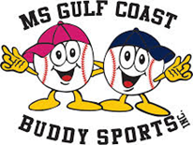 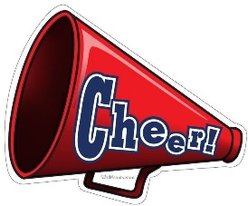 

Sponsor Form

MS Gulf Coast Buddy Sports, Inc. continues to provide recreational Buddy Ball baseball and Cheerleading to youths and adults with special needs through our Buddy Sports programs.

This year we are adding Kick-ball and Fishing to our activities.

Your contribution will help provide jerseys, volunteer/sponsor t-shirts, equipment, trophies, snacks, and other needed items at no cost to the players or families. Sponsors receive a t-shirt, team plaque, and name/logo recognition on sponsor banner, website, and Facebook page, and other various media if they so desire. Please help us to keep providing these programs for free.

Suggested Sponsor Amount: _____ $250.00 another amount or gift ___________________

**Donate electronically on our web page** [www.msgulfcoastbuddysports.org](http://www.msgulfcoastbuddysports.org)

**or**

**Make Checks Payable to:**  **MS Gulf Coast Buddy Sports**

**23155 Stablewood Circle**

**Pass Christian, MS 39571**

Thank you,

Mike Crawford, Founder, Executive Director

MS Gulf Coast Buddy Sports, Inc.

Cell: 228-860-9055

[crawfordmike51@gmail.com](mailto:crawfordmike51@gmail.com)

Stella Wolf, Secretary

MS Gulf Coast Buddy Sports, Inc.

Cell: 228-760-0591

[wolfpierce@aol.com](mailto:wolfpierce@aol.com)

**MS Gulf Coast Buddy Sports, Inc. is a registered 501(c)(3) public charity recognized by the IRS.**

**IRS: EIN 38-3953394 State of Mississippi: Business ID 1059151**

**Web site:** [**www.msgulfcoastbuddysports.org**](http://www.msgulfcoastbuddysports.org) **Facebook: BuddyBall@MSGulfCoastBuddySports**

**Sponsors get their name on the volunteer t-shirt and banner. Please indicate your preference for “Thank You” recognition: plaque________ or picture________ or letter________ or none______**